Module 4 Homework Extension
John Doll
9/30/2020

1: Moving Average for Ohio and Butler County
#read in data
ohioDF <- read_csv("https://coronavirus.ohio.gov/static/COVIDSummaryData.csv")
#filter out row of totals and mutate variables
ohioDF <- ohioDF %>%
filter(Sex != "Total") %>%
mutate(AgeFactor = factor(`Age Range`), OnsetDate = mdy(`Onset Date`))
#group data for Ohio by OnsetDate and summarize the cases and dead
ohioDateDF <- ohioDF %>%
group_by(OnsetDate, County) %>%
summarize(ncases = sum(`Case Count`),
ndead = sum(`Death Due to Illness Count`, na.rm = TRUE))
#create Butler county data set and summarize the cases and dead
butlerDF <- ohioDF %>%
filter(County == "Butler") %>%
group_by(OnsetDate) %>%
summarize(ncases = sum(`Case Count`),
ndead = sum(`Death Due to Illness Count`, na.rm = TRUE))
Today <- Sys.Date()
ggplot() +
labs(x = "Onset Date", y = "Number of New Cases", title = "Ohio Case Counts", subtitle =
paste("Updated: ", Today, source =
"https://coronavirus.ohio.gov/static/COVIDSummaryData.csv")) +
theme_minimal() +
geom_ma(data = ohioDateDF, aes(x = OnsetDate, y = ncases), n = 7, linetype = 1, color =
"black", size = 1.25) +
geom_ma(data = butlerDF, aes(x = OnsetDate, y = ncases), n = 7, linetype = 1, color =
"red", size = 1.25) +
annotate(geom = "text", x = date("2020-08-25"), y = 125, label = "Butler County")
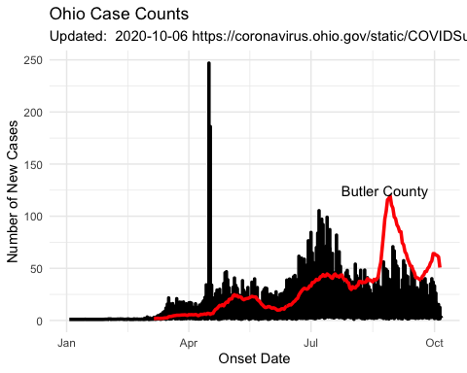
It is interesting to see the massive spike in April due to the Marion county jail outbreak. The graph shows a curious curve that rises and falls across the year. It is also interesting to see the massive Butler county case spike as students returned to Oxford.

2: Cases Per County for People Aged 30 and Younger
#filter for the ages we want, group by county, and total the cases and dead
ohioAgeDF <- ohioDF %>%
filter(AgeFactor == "20-29" | AgeFactor == "0-19") %>%
group_by(County) %>%
summarize(ncases = sum(`Case Count`),
ndead = sum(`Death Due to Illness Count`, na.rm = TRUE))
totalCases = sum(ohioAgeDF$ncases)
ggplot(ohioAgeDF, aes(ncases, fct_reorder(County, ncases))) +
geom_point(size = .75) +
labs(x = "Number of Cases", y = "County", title = "Cases per County in Ohio", subtitle =
paste("Updated: ", Today, source =
"https://coronavirus.ohio.gov/static/COVIDSummaryData.csv")) +
theme(axis.text.y = element_text(size = 5))
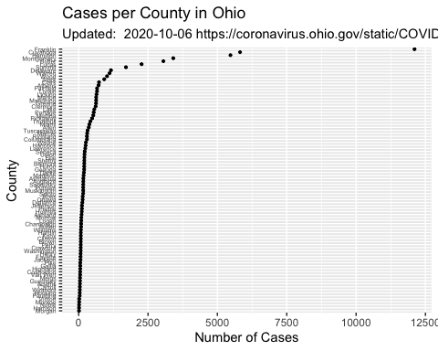
Clearly Franklin County has had the most cases. It’s worth pointing out that the top 5 counties (Franklin, Cuyahoga, Hamilton, Montgomery, and Butler) in terms of cases make up over 50% (28654/52092 = 55%) of the total cases for people under the age of 30 in Ohio. This pattern is very likely due to students returning to school and being in large crowds with a mix of many different people.

3: Plot of Ages of the Dead
ohioDateDF <- ohioDF %>%
filter(AgeFactor != "Unknown") %>%
group_by(AgeFactor) %>%
summarize(ncases = sum(`Case Count`),
ndead = sum(`Death Due to Illness Count`, na.rm = TRUE))
ggplot(ohioDateDF, aes(x = AgeFactor, y = ndead)) +
geom_col(color = "grey") +
geom_text(aes(label = ndead), vjust = -0.2) +
theme(axis.text.y = element_blank(), axis.ticks.y = element_blank()) +
labs(x = "Age Group", y = "", title = "Number of Deaths by Age Group in Ohio")
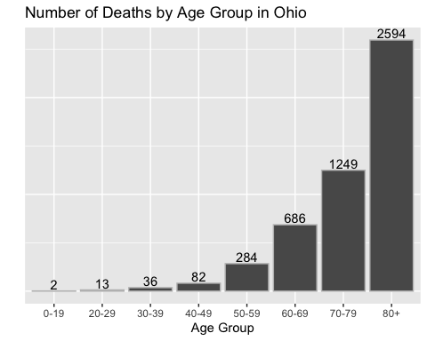
#Used https://r-graphics.org/index.html for finding formulas as well as old assignments
This graph highlights what has been the unfortunate truth for the elderly in terms fighting coronavirus. However, it is reassuring to see that young people are quite good fighters against the disease.

